PPS MID-1 CODES
- (a) Write a C-Program to arrange the given elements in ascending order using Quick Sort Algorithm. (Read 10 elements from the User)
Prog.
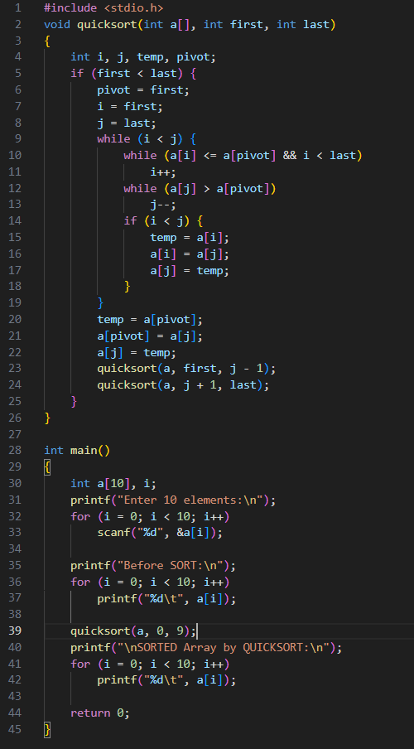

(b) Write a C-Program to check if the given String is a Palindrome or Not.
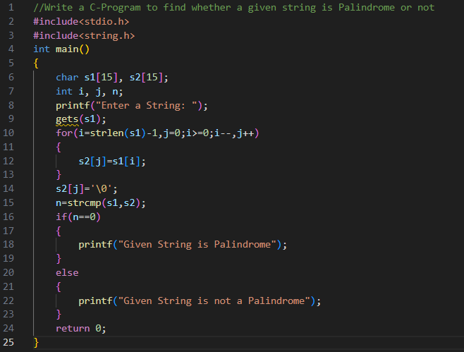

- (a) Write a C-Program to arrange the given elements in Ascending Order using Selection Sort Algorithm. (Read 10 elements from the User)
Prog.
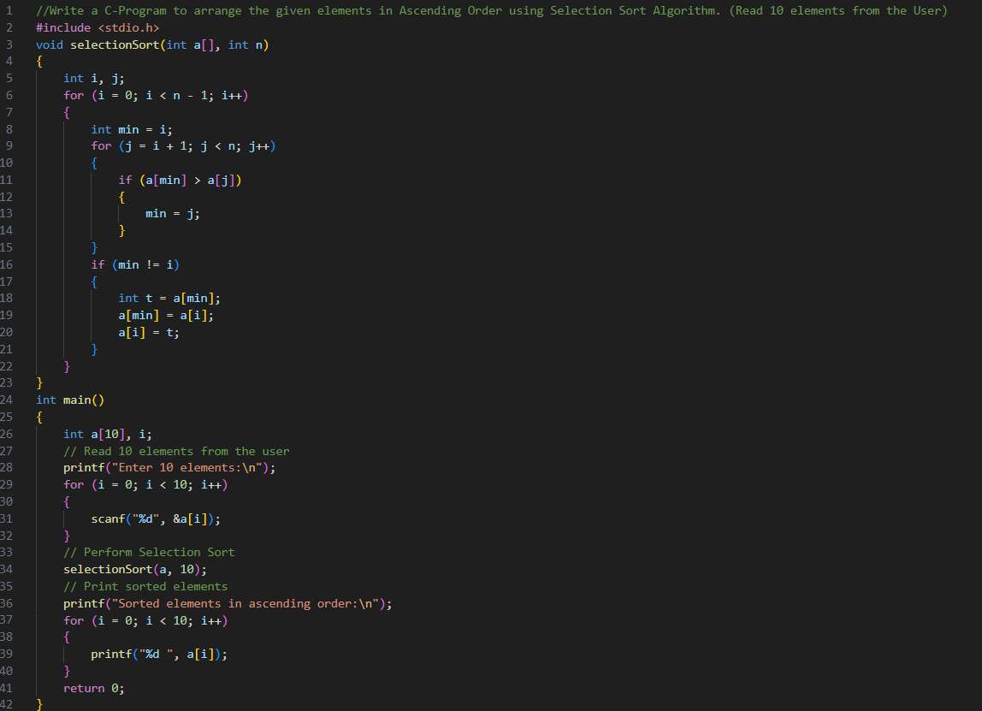
(b) Write a C-Program to print the number of Vowels and Consonants in a given String.
Prog.
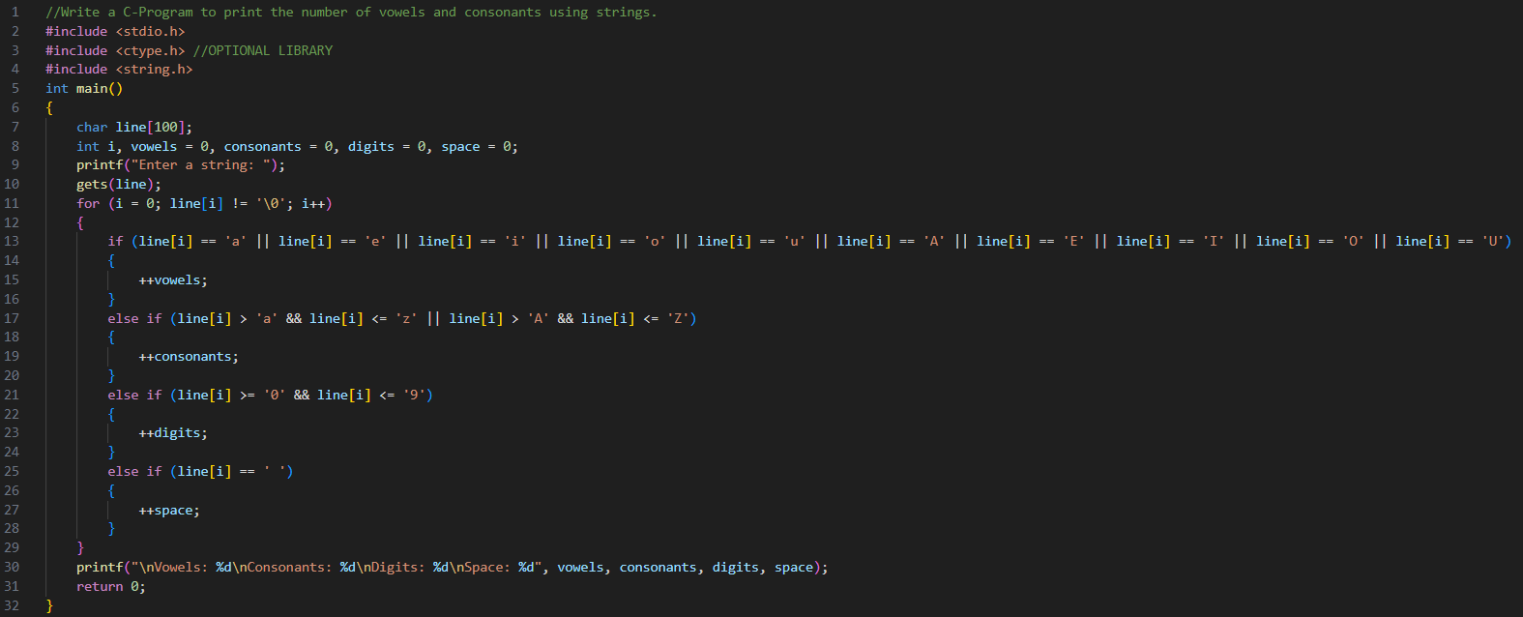

- (a) Write a C-Program to arrange the given elements in Ascending Order using Insertion Sort Algorithm. (Read 10 elements from the user)
Prog.
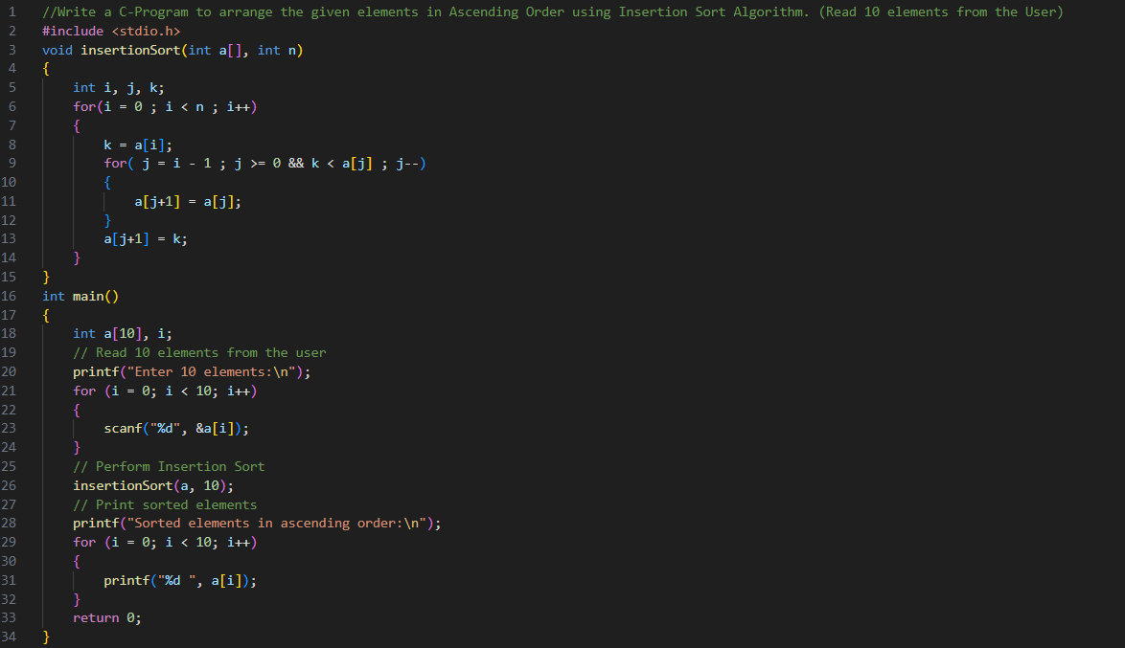
(b) Write a C-Program to delete number of characters from a given string at given position.
Prog.
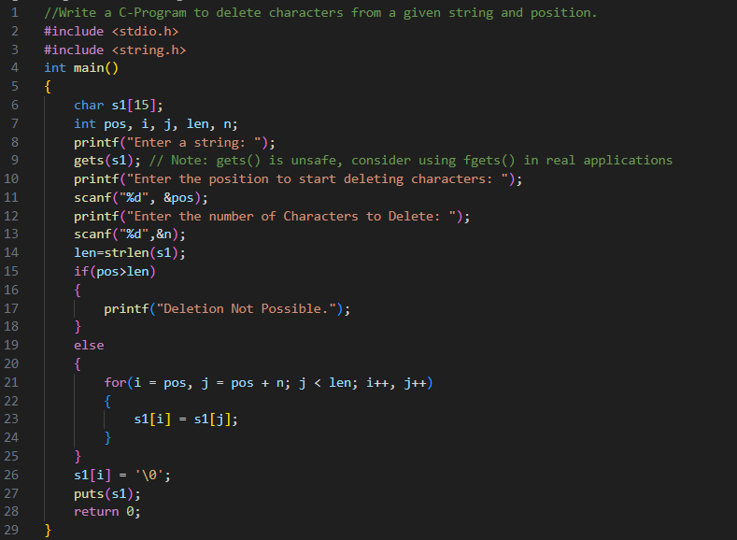
- (a) Write a C-Program to search the given element in an array using Binary Search. (Read 10 elements from the user)
Prog.
FOR GIVEN SORTED ARRAY
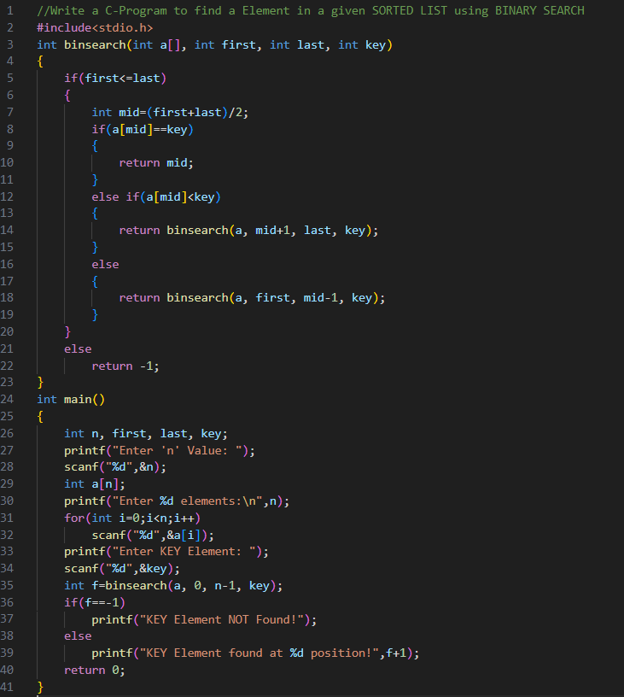

FOR GIVEN UNSORTED ARRAY

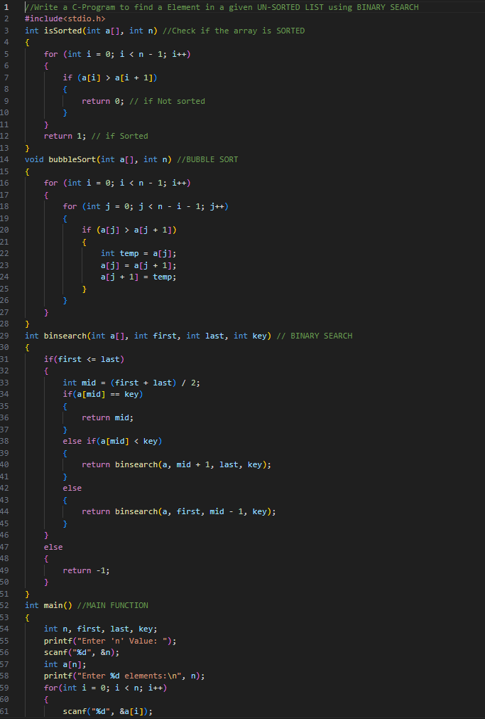
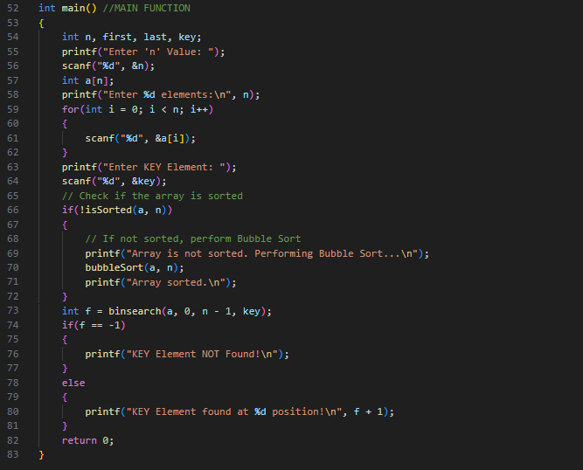
(b) Write a C-Program to Calculate Addition of two Complex Numbers using Structures.
Prog.
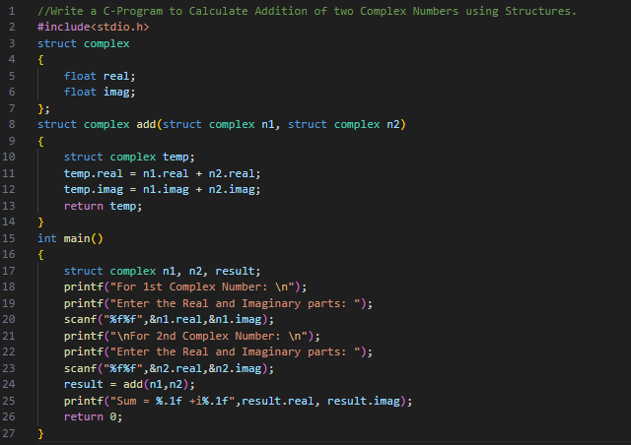
- (a) Write a C-Program to search the given element in an array using Linear Search. (Read 10 elements from the user)
Prog.
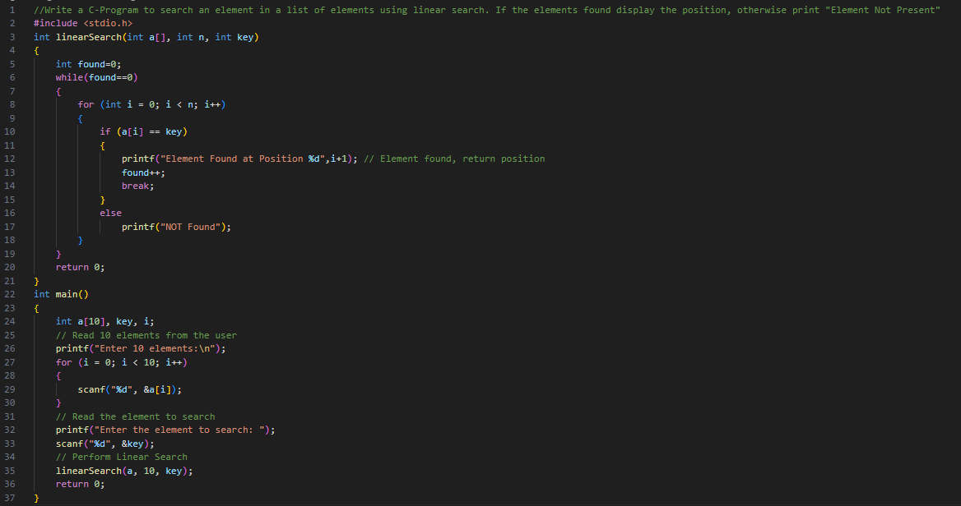
(b) Write a C-Program to read and Print student’s details using Array of Structure Concept.
Prog.
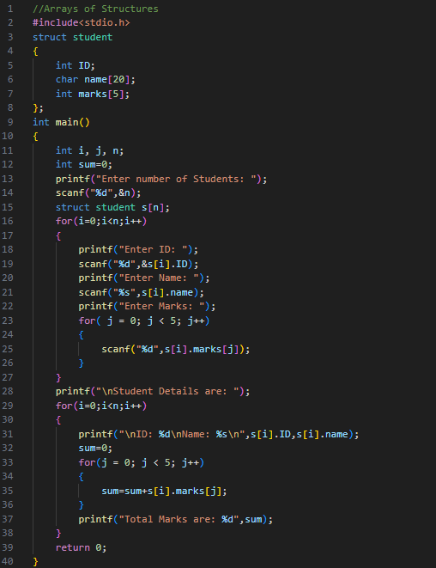
- (a) Write a C-Program to insert number of characters from a given string at a given position.
Prog.
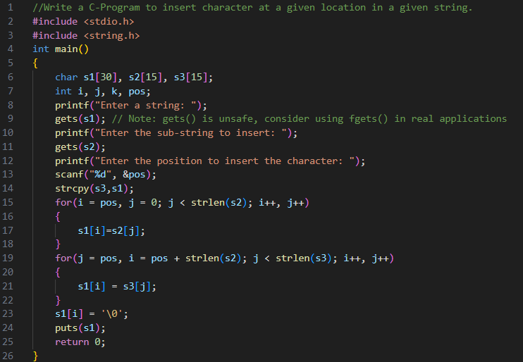
(b) Write a C-Program to Convert Roman to Decimal Number
Prog.
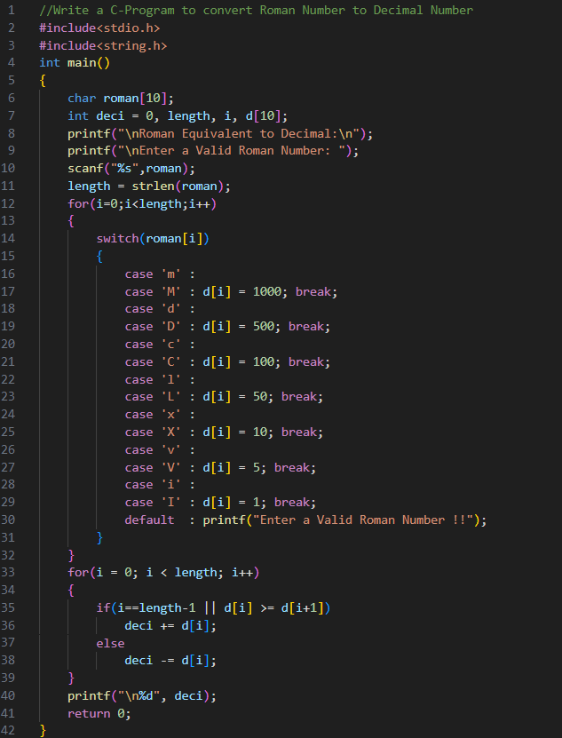
- (a) Write a C-Program to find 2’s Compliment of a given number.
Prog.
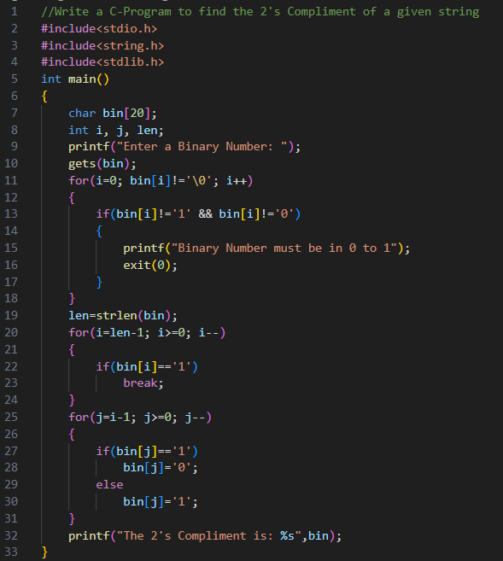
(b) Write a C-Program which calculates multiplication of two complex numbers using structures.
Prog.
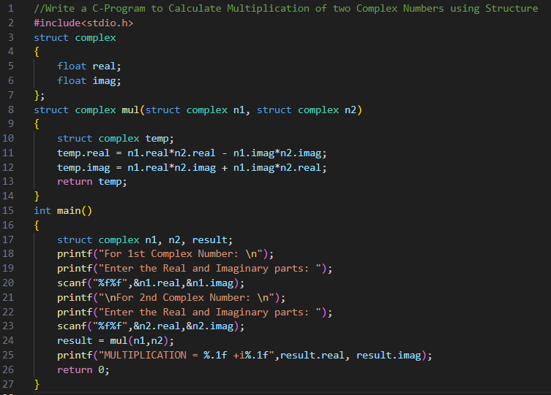
- (a) Write a C-Program to Implement BIT-FIELDS in structures:
Prog.
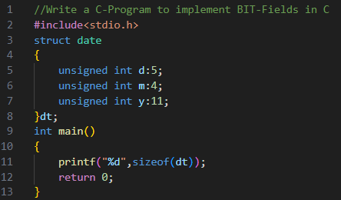
(b) Write a C-Program to read details of student using UNIONS:
Prog.
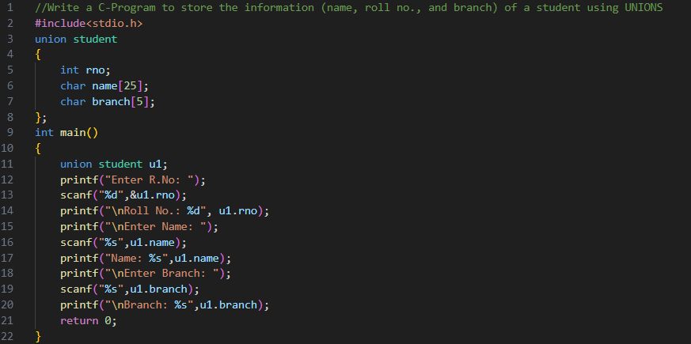

(c) Write a C-Program to input a String at least one number print square of that number
